Parent/Carer Consent Form:
Interaction with Chester the Therapy Dog
Chester is a friendly and experienced cockapoo with over 6 years of service in schools and care settings for both adults and children. He joins our Pupil Referral Unit (PRU) to support the emotional and social development of our students. Chester has attended dog obedience classes and though he can be naughty (the students love this side of Chester!), he has no history of aggression and has been socialised around children and adults with MHD in multiple settings for over five years. These include at least two different schools, multiple care homes and an adult care home.

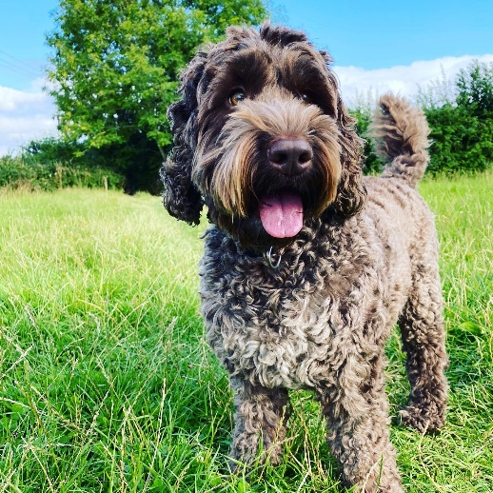
Chester
All interactions with Chester are entirely voluntary and will always be supervised by trained staff. Students will never be required to interact with Chester if they do not wish to, and appropriate hygiene and safety measures are in place.
Please complete the form below to indicate your consent for your child to interact with Chester and return to kim.harmsworth@pathwayslearningcentre.org via email or leave at Reception..
Student Name: ____________________________________________
Parent/Carer Name: _______________________________________
Signature: _______________________________________________
Date: ___________________________________________________
Medical Conditions or Allergies (including pet allergies):
______________________________________________________________________

