About this toolkit
Schools play a vital role in connecting families with the support available to them. You may have already received, or will shortly receive, a posted pack of printed materials to place in public locations in your school setting. This digital toolkit has been created alongside these materials to make it as easy as possible to share clear, trusted information about financial help and cost of living support with parents and carers in South Gloucestershire.
Whether through newsletters, websites, social media, parent apps or other communication channels, we hope this information helps to raise awareness of the assistance that families may be entitled to.
The toolkit includes:
- Guidance on free school meals, including changes to eligibility from September 2026 and how families can apply.
- Information about the Holiday Activities and Food (HAF) programme, including who is eligible and how families can access free holiday activities and meals.
- Information about Universal Credit, including how to check eligibility and where to get help making a claim.
- Information about the Crisis and Resilience Fund for low-income households experiencing an unexpected financial shock, such as bereavement, job loss or an unforeseen expense.
- Details of wider cost of living support, including help with food, energy bills, housing costs, budgeting, debt advice and family support.
- Information about the Summer, Sorted! campaign, helping families find free and low-cost activities, local events and practical support during the summer holidays.
Many families may not realise that claiming Universal Credit can unlock access to a range of additional support, including expanded eligibility for free school meals from September 2026. By sharing this information, schools can help ensure eligible children receive the support they are entitled to, including targeted or expanded free school meals and, where applicable, the additional funding available to support their education.
Below, you'll find ready-to-use copy for your usual communication channels, such as newsletters, websites, parent apps and social media.
Thank you for helping us reach families across South Gloucestershire. We greatly value the trusted relationship schools have with their communities and your continued support in ensuring parents and carers know where to turn for advice and assistance when they need it.

Free School Meals

Text: Free School Meals – check if your child is eligible
There are now three ways children can receive free school meals.
Targeted free school meals are available for children whose household receives Universal Credit or certain other benefits and has an annual household income of £7,400 or less. As well as free school meals throughout their education up to age 19, eligible children can also access additional support, including the Holiday Activities and Food (HAF) programme, while schools receive extra funding to support their learning.
Expanded free school meals, available from September 2026, are for children whose household receives Universal Credit with annual household earnings above £7,400. These children will also receive free school meals throughout their education up to age 19.
Universal infant free school meals continue to provide free school meals for all children in Reception, Year 1 and Year 2.
Parents and carers are encouraged to apply for targeted or expanded free school meals as soon as their child starts Reception to ensure they receive all the support they are entitled to. Eligibility is checked annually.
Find out more and apply at: www.southglos.gov.uk/freeschoolmeals

Suggested image: 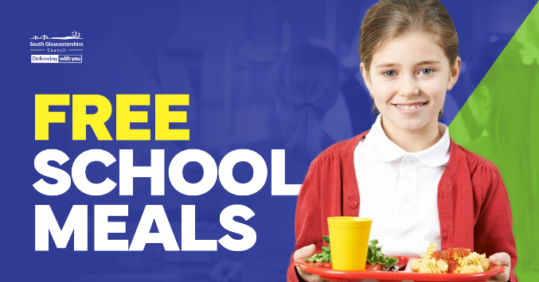

Holiday Activities and Food programme (HAF)

Text: If your child receives targeted free school meals (previously known as benefits-related free school meals), they may be eligible for a free place on South Gloucestershire Council's Holiday Activities and Food (HAF) programme.
During the Easter, summer and Christmas holidays, children aged 5-16 can enjoy a range of activities including sports, arts and crafts, cooking, theatre and much more, while also receiving a healthy, nutritious meal.
Please note that free HAF places are not available for children receiving expanded free school meals or universal infant free school meals. However, many providers also offer paid places.
To find out more or book a place, visit www.southglos.gov.uk/HAF or email HAF@southglos.gov.uk

Suggested image: 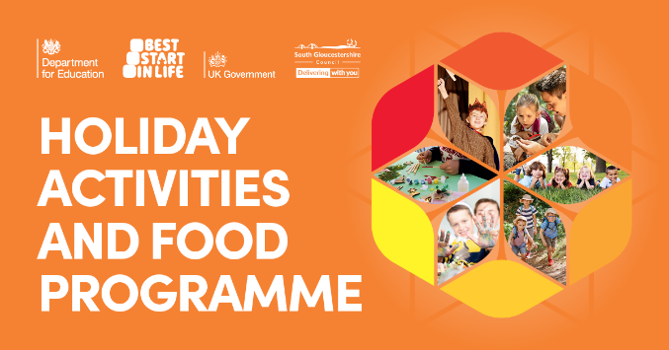

Universal Credit
Text: If you live in a low income household or need help with living costs, you may be entitled to Universal Credit.
As well as helping with everyday household costs, Universal Credit can unlock access to other support, including help with energy bills, healthcare costs, social tariffs and, from September 2026, free school meals for eligible children throughout their education up to age 19.
You can check your eligibility and apply online at www.gov.uk/universal-credit
If you live in South Gloucestershire and would like help with your application, South Glos Citizens Advice offers a free Help to Claim service.
Call 0800 144 8444 or visit www.southgloscab.org.uk

Suggested image: 

Crisis and Resilience Fund

Text: If you've experienced an unexpected change in your financial circumstances, South Gloucestershire Council may be able to help through its Crisis and Resilience Fund.
The fund provides emergency financial support to eligible low-income households facing immediate or longer-term financial difficulties.
To apply, you must:
- Live in South Gloucestershire
- Be aged 18 or over

Applications require personal details, information about your income and spending, and recent bank statements.
Find out more or apply online at www.southglos.gov.uk/crisis-and-resilience-fund, visit a One Stop Shop in Kingswood, Patchway or Yate, or call 0800 953 7778.

Suggested image: 

Financial support

Text: If you're finding things difficult, you're not alone. South Gloucestershire Council and local partners offer a wide range of support for residents.
Help is available with:
- Housing costs and Council Tax Reduction
- Debt and budgeting advice
- Energy bills and seasonal support
- Food support
- Low-cost activities for families and children
- Advice on staying warm in winter and cool during hot weather
To explore the support available and find out what you may be entitled to, visit the South Gloucestershire Council Cost of Living Hub at www.southglos.gov.uk/costofliving

Suggested image: 

Summer, Sorted!

Text: Looking for affordable ways to keep the children entertained this summer?
South Gloucestershire Council's Summer, Sorted! campaign is packed with free advice, low-cost activities, family days out and practical ideas to help make the school holidays fun without stretching the budget.
The team will also be visiting shopping centres across South Gloucestershire during the summer holidays, offering advice, family activities, giveaways and information about local support services, including help with stopping smoking and getting back into work.
The campaign is delivered in partnership with Mamas Bristol, who support families with the cost of living, wellbeing and community connections.
To find out more visit www.southglos.gov.uk/seasonal-support

Suggested image: 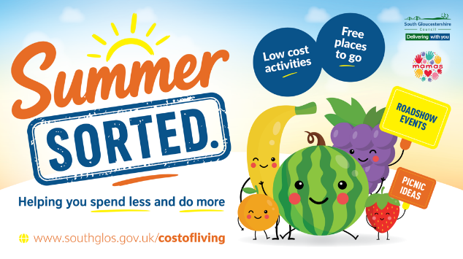

Contact information
Chantelle MacGowan
Campaigns Officer
Strategic Communications
Chantelle.Macgowan@southglos.gov.uk
www.southglos.gov.uk

